execution time (ms) (ms)

Left to right: MSM_O, MLite_O, EUML_O,

Sine_N, Sine_O, QM_N, QM_O, OurTool_N, OurTool_O

Left to right: MSM_O, MLite_O, EUML_O,

Sine_N, Sine_O, QM_O, OurTool_N, OurTool_O

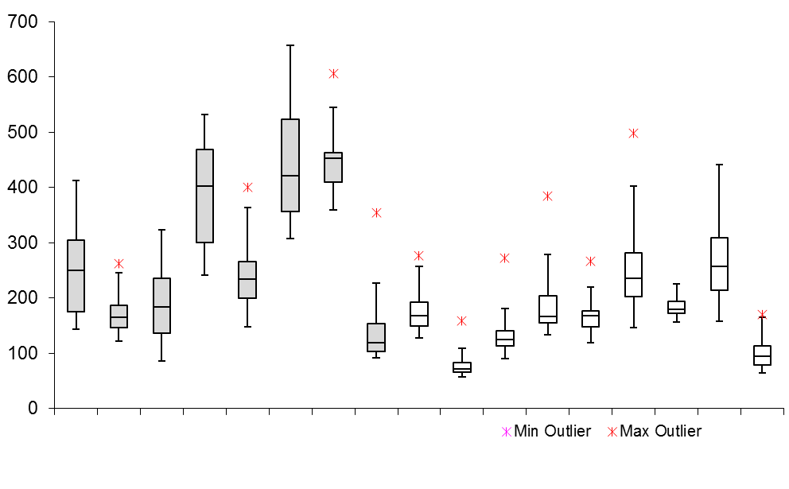

Simple benchmark

Composite benchmark